Predicate Adjective

✅ What Is a Predicate Adjective?
# Source: AI Source: Provided by: [Data Path: Persons Table -> ID Column: 1, Name_En Column: Motasem Essam] -> From: [ChatGPT] on [8/4/2025]
A Predicate Adjective is an adjective that follows a linking verb and describes the subject of the sentence.
It is a type of subject complement and a subcategory of Nominal Predicate.

🔸 Key Features:
# Source: AI Source: Provided by: [Data Path: Persons Table -> ID Column: 1, Name_En Column: Motasem Essam] -> From: [ChatGPT] on [8/4/2025]
- Follows a linking verb (e.g., is, are, seems, feels, becomes).
- Describes a quality or state of the subject.
- Functions grammatically as an adjective.
- Helps complete the meaning of the verb by describing the subject.

🔸 Examples:
# Source: AI Source: Provided by: [Data Path: Persons Table -> ID Column: 1, Name_En Column: Motasem Essam] -> From: [ChatGPT] on [8/4/2025]
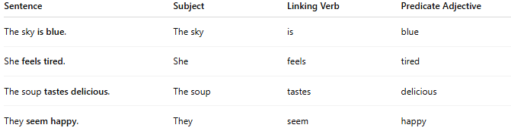
Sentence | Subject | Linking Verb | Predicate Adjective
The sky is blue. | The sky | is | blue
She feels tired. | She | feels | tired
The soup tastes delicious. | The soup | tastes | delicious
They seem happy. | They | seem | happy

🔸 Test for Predicate Adjective:
# Source: AI Source: Provided by: [Data Path: Persons Table -> ID Column: 1, Name_En Column: Motasem Essam] -> From: [ChatGPT] on [8/4/2025]
Try asking “What is the subject like?”
- “The sky is blue.” → What is the sky like? → Blue ✅

🔸 Compare with Predicate Nominative:
# Source: AI Source: Provided by: [Data Path: Persons Table -> ID Column: 1, Name_En Column: Motasem Essam] -> From: [ChatGPT] on [8/4/2025]
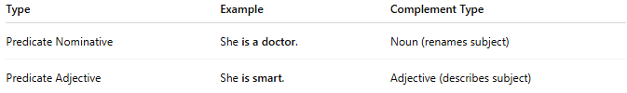
Type | Example | Complement Type
Predicate Nominative | She is a doctor. | Noun (renames subject)
Predicate Adjective | She is smart. | Adjective (describes subject)

